Method
With more experience in python, I used python as the programming library for many other sections of the code. Having the idea for a game as the center of the design, I chosen pygame library to build a game. To make the game simple, I followed a simple 2D pygame tutorial taught electronically by Sentdex. From the tutorial and trying to understand the code, I modified and added other features to the game and added another idea of game developers needing to see if the game is satisfactory other than rating and that is usability.

With any game developer, they would want to know if the game was satisfactory to the users, to get the information, the game needs a client to send information to a server, in this case, a simple python client-server would work. The client sends everything in a string to a simple server that would format the string into data and saved in a database using a sql connector.

The goal of data collection is to, first of all, identify a person uniquely, find their high score, and how many times they have played. First, there is a need to identify the person, a simple user login would do, however I wanted to try a new method, using a simple mac address to identify the person. Secondly, the user account name can be used to allow many accounts to remain active on the same mac address. Third, the high score shows the difficulty of the game to game developer if they held an average score of all players, since the developer can set a average high score for all users from the start. Fourth, with the counter of times played, if a program has more than one game, while one is played more times than others, a person can see what could have a greater attraction to the players and how to structure the others. In this case, a rough example and simple program with one game is decided on.

Conveniently, the scripting language, django was also built mainly out of python and is a web development tool that works with html files and a database. This goes well with the pygame idea as I planned to collect gaming data and player information by placing them into a structured database. Django can connect the database to an html file which can display all desired information.

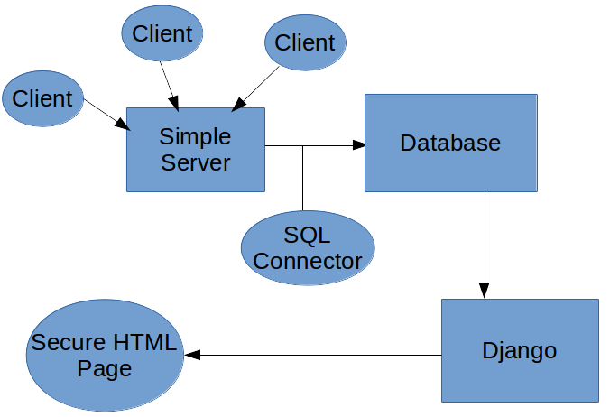
Image 1
Image 1: A simple diagram where a game client from the user connects with the server to send data into the data base using an SQL connector. That database is accessed using the django program coupled with a html server.

As for the game, after following the tutorial from Sentdex, I tried to improve the game in one page using different menus and effects which made a shaky structure of code where at one point, I could not find the main error that caused multiple failures, basically a monolithic structure with a few functions. To solve the problem, a more distributed structure with many more converted into functions where a broken code does not affect an entire file the code in the program was decided on. The direct benefit of the distributed structure was the code being easier to test and troubleshoot code for me. I isolated all independent variables and sectioned functions into different python files to be imported. As the code grew, the downside to the distributed code was the file naming when having to head back into the previous code to test the errors. As I randomly named the files, it was hard to pinpoint files to modify and all imports import all defined variables under the symbol *. In this case, there needed to be a massive reorganization to rename files was needed to ensure all files names matches their function.

The game design is about a block that falls towards the player. At the start there is a menu for help, high score, and a play button. To play the game, the player is required to dodge the falling block on the matrix using the keyboard. If there is a collision, the game ends, and the three current high scores are kept. As the game, is played, two counters are kept, one for in-game score and the second is the times played. In addition, should there be a need to pause, a pause menu for the button ‘p’ was implemented and a game over screen was added to quickly restart the game or exit.
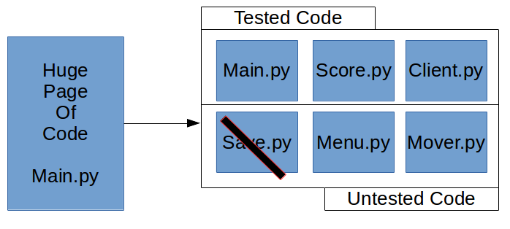
Image 2
Image 2: As errors in the code block appeared and attempts to fix the error caused another, a solution that each code can be split into parts and tested individually to ensure that the program function in a desired way. In case of an error, the code can be ran separately and revised without accidentally modifying the other code. The disadvantage to this was when I initially gave random names like two.py for menu.py. With similar circumstances to the rest and the size expanded, managing the code became tedious. As such, I realized, for convenience, naming was important as the code expanded for this method.

After the game functioned in a desired way, the current game needed to write data out to a file that a server can send to the server. To hide the file from prying eyes, a python library, os, changed the directory and created a folder to move into. With this folder, the file can be hidden, but as I currently use a linux system, the file adds a dot in front of the file to ensure the file is hidden in the directory. Using the hidden directory, data can be saved in separate formats to ensure the data is safely sent and used in a correct format.

